Turton

Year 9 Easter Update

A springtime update on what year 9 pupils have been learning this term, just in case they are becoming less forthcoming with age! All of our knowledge organisers, which detail exactly what will be on our end-of-year tests are here on the Turton website. http://www.turton.uk.com/ks3revision/  - English: Modernism, WW1 Poetry, The changing role of women (Virginia Woolf, T.S. Eliot, Imagism, The Lost Generation)  - Maths: Pythagoras, Statistics, Re-arranging formulae (Simultaneous & quadratic equations, angles & bearings, compound measures)  - Science: Homeostasis, Extraction of metals, and magnetism (Climate, atomic structure, periodic table, nervous and endocrine systems)  - History: The Holocaust , WW2 (Fascism, Fascist ideology)  - Faith & Ethics: War and Peace, Holy War and Crusades, Terrorism and Jihad (Buddhism)  - Geography: Plate tectonics, Coasts & coral reefs, farming, globalisation (greater depth)  - Spanish: Technology, daily routine, relationships & global issues (Environment)  - French: Future plans, jobs and pocket money (Extended grammar)  - Drama: Review, ‘Blood Brothers’, Scripted performance, Jobs in Theatre  - PE: Physical training, Drugs in sport  - Computing: Hardware and software, CPU performance, Embedded systems  - Digital IT – UX and UI  - Music: Composition, using Sibelius  - Technology: History of Fashion, Design, Social, Moral and Environmental Impact  - Art: Controversial Art, Nunzio Paci Art Graphics: Typophoto, Lazlo Maholy Nagy | 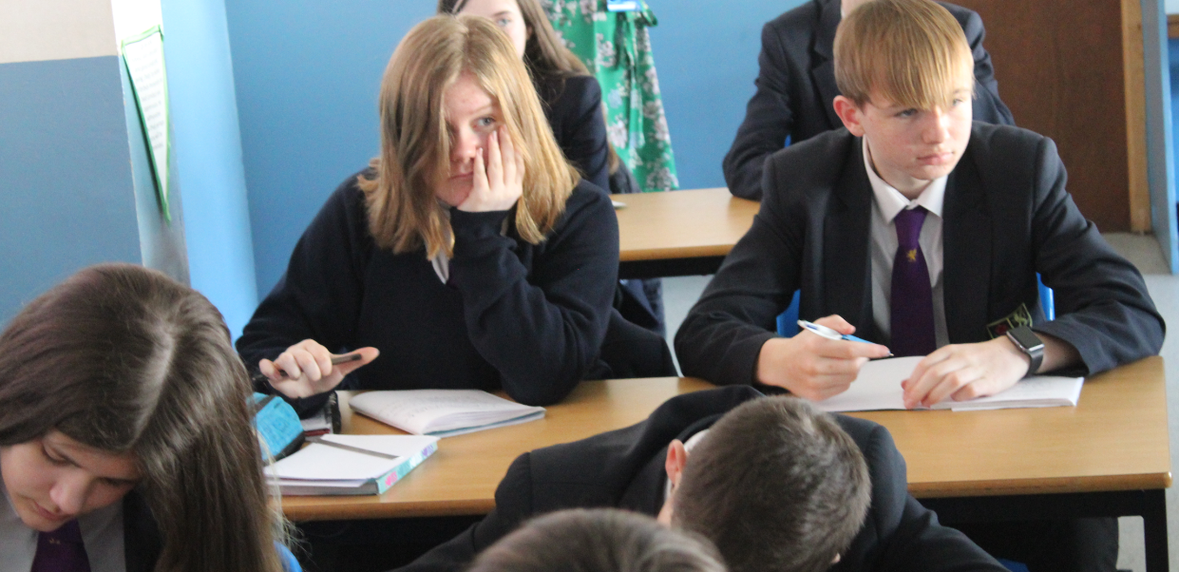
 | 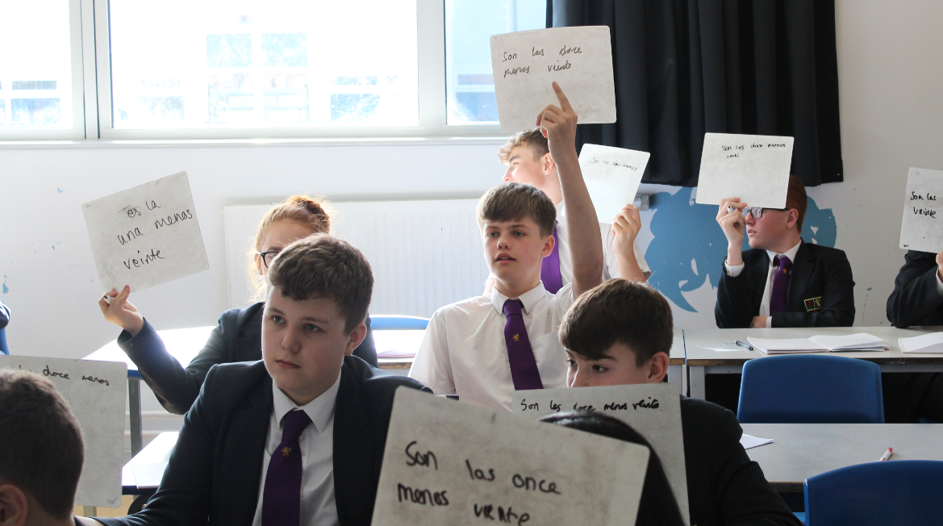

“The cure for boredom is curiosity. (There is no cure for curiosity.)”
Ellen Parr
F.O.M.O. (Fear of missing out)  Education moves the world forward, and in the time of so much information being thrust at us all, every minute of every day, it is vital that good education for our students helps them to be the movers and shakers of all our futures. Teaching at Turton is superb, and having superb attendance helps all students to fully access their education. Simple things like hand washing and good hygiene can reduce the spread of bugs dramatically and help all students to attend school fully.  Mrs Bach (Deputy Head Teacher)  Working backwards!  Year 9 have been busy preparing to decide on their Pathway Subjects for Key Stage 4. We have dedicated a large amount of time with Career’s events, Pathway’s Evening and subject assemblies. The theme we’ve been looking at is: thinking forward and working backwards. Year 9 have been trying to envisage themselves in the future and what steps need to be taken to get there. We hope that they continue with the same maturity and positive work ethic.  Miss Brown (Head of Year 9) |  | 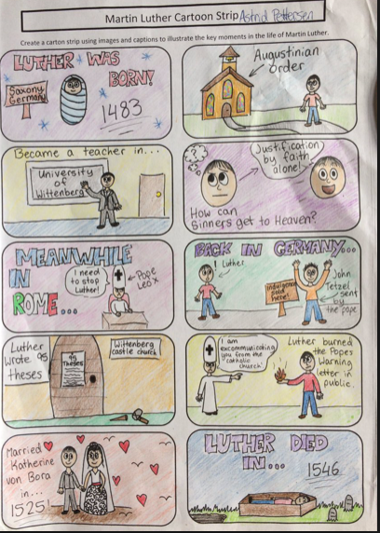  Learning top tip #2  Storyboarding is a great tool if you need to learn the order of something. This can be in every subject, not just English, but what about the story of cells in Biology for example. Don’t forget to actually memorise the story once you’ve created it.  Mrs Lane (Assistant Head Teacher)  Curiosity Question – Faith & Ethics  Can an omnipotent being create a rock so heavy that they can’t lift it? (Ask your Faith & Ethics teacher for the answer!)  Mr Greenhalgh (Head of Faith & Ethics)

Recommends  Toffee – Sarah Crossan  When Allison runs away from home she doesn't expect to be taken in by Marla, an elderly woman with dementia, who mistakes her for an old friend called Toffee.  Allison is used to hiding who she really is, and trying to be what other people want her to be. And so, Toffee is who she becomes. But as her bond with Marla grows, Allison begins to ask herself -where is home? What is a family? And most importantly, who am I, really? (The whole book is written in verse!)  The Hitchhikers Guide to the Galaxy – Douglas Adams  Seconds before the Earth is demolished to make way for a galactic motorway, Arthur Dent is plucked off the planet by his friend Ford Prefect, a researcher for the revised edition of The Hitchhiker's Guide to the Galaxy who, for the last fifteen years, has been posing as an out-of-work actor. Together this dynamic pair begin a journey through space aided by quotes from The Hitchhiker's Guide ("A towel is about the most massively useful thing an interstellar hitchhiker can have") and a galaxy-full of fellow travellers.  Let me know what you think – Mrs Locke (Librarian) | 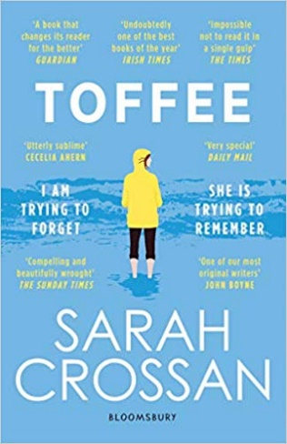  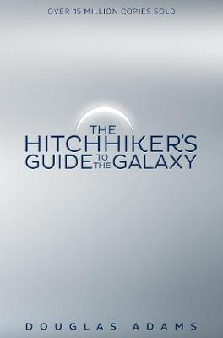

Jump in
Just to let you know about some of the marvellous things going on that pupils can be involved in to really make the most of their time at Turton. This term:
Showcase Vocal Group – Performance coming up. If you want to be involved with the performance, it’s never too late. See Miss Hale or Miss Helmn ASAP!
Miss Hale (Music Teacher) & Miss Helmn (Drama teacher)

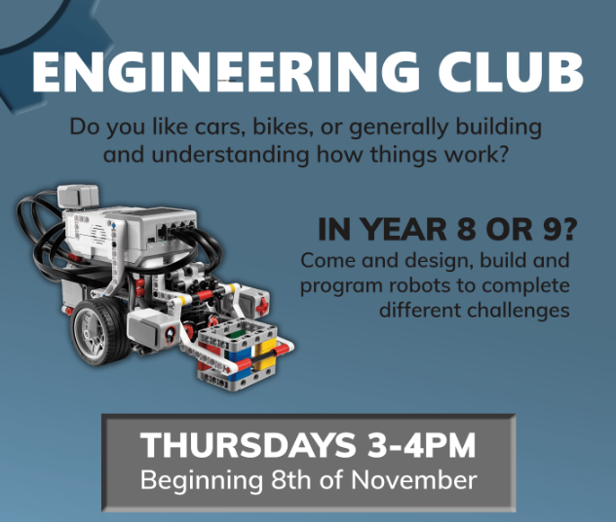
Engineering Club: If you like cars, bikes or generally building things. Then speak to Mr Little about joining this group. Every Thursday 3-4pm in the technology rooms. Limited spaces available.
Mr Little (Maths/Technology teacher)

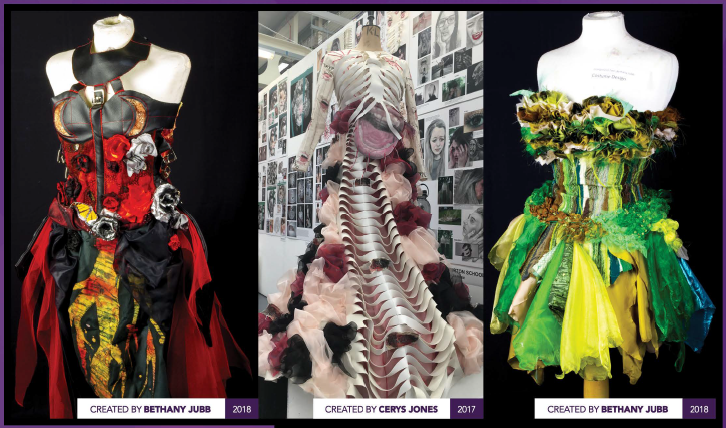
Spotlight: A-level Art: Textiles

Each term we’ll spotlight an A-level course at Turton, just in case pupils are wondering where excellent learning can take them. Information about all courses is available in our prospectus here: http://www.turtonsixthform.uk.com/
Mrs Bali (Head of Sixth Form)
