Turton

Year 8 Easter Update

A springtime update on what year 8 pupils have been learning this term, just in case they are becoming less forthcoming with age! All of our knowledge organisers, which detail exactly what will be on our end-of-year tests, are here on the Turton website. http://www.turton.uk.com/ks3revision/  - English: Neo- Classical, ‘Lord of the Flies’, The rise of the novel (Gulliver’s Travels, Pope’s Heroic Couplets, Satire)  - Maths: Solving equations, fractions, percentages (recurring decimals and fractions, sequences, linear graphs)  - Science: Respiration, metals & non-metals, waves and photosynthesis  - History: Revolutions: Glorious, Scientific, American, French (Empire & Slavery)  - Faith & Ethics: Prejudice, refugee crisis (Political philosophy & Karl Marx)  - Geography: African Biomes, Poverty and development in Africa  - Spanish: Fashion, Town, Holidays (French: Last weekend (past tense) and holidays)  - Drama: Live theatre review, Dialectic Theatre, Brecht (Mantle of the expert)  - PE: Joints for movement, Diet for performers  - Computing: Python programming, abstraction (solving computational problems)  - Music: Music for Film and Media, The Blues (Composition & chords)  - Technology: Dying & techniques, food provenance & pastry, construction & finishing methods  - Art: Cubism, Picasso, Braque, Juan Gris, Portraiture, (Still Life and sculpture) | 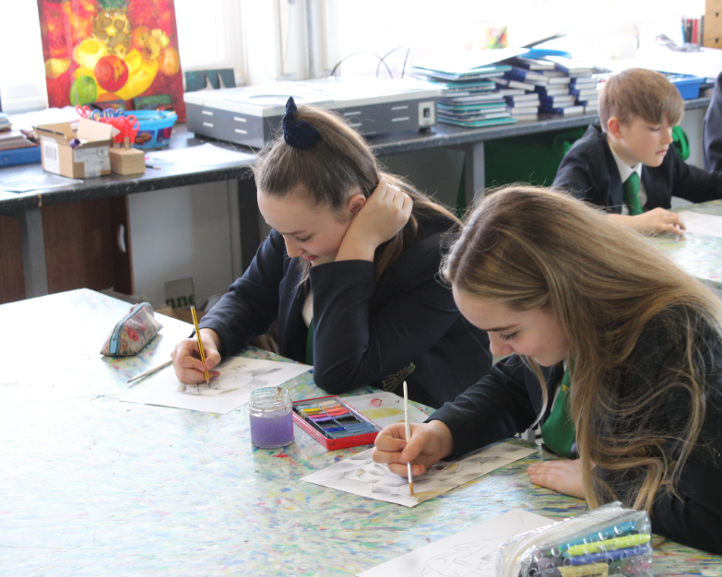
 | 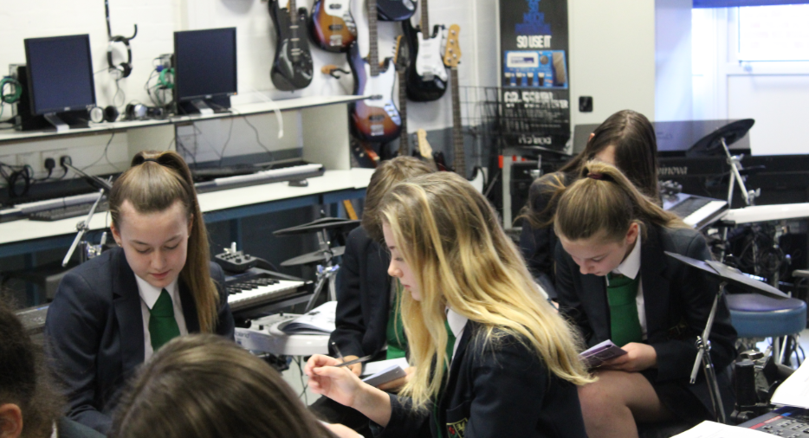

“Curiosity is the most powerful thing you own”
James Cameron
F.O.M.O. (Fear of missing out)  Education moves the world forward, and in the time of so much information being thrust at us all, every minute of every day, it is vital that good education for our students helps them to be the movers and shakers of all our futures. Teaching at Turton is superb, and having superb attendance helps all students to fully access their education. Simple things like hand washing and good hygiene can reduce the spread of bugs dramatically and help all students to attend school fully. Mrs Bach (Deputy Head Teacher)  You are the choices you make  Year 8 are now moving towards making their mini options choices. Over the coming weeks options subjects will be joining us in assembly so pupils are able to make well-informed decisions. In-keeping with the notion of positive choices, we have also been exploring the idea of ‘humanity, with a focus on kindness and how students relate to one another. Mrs Smith (Head of Year 8) |  | 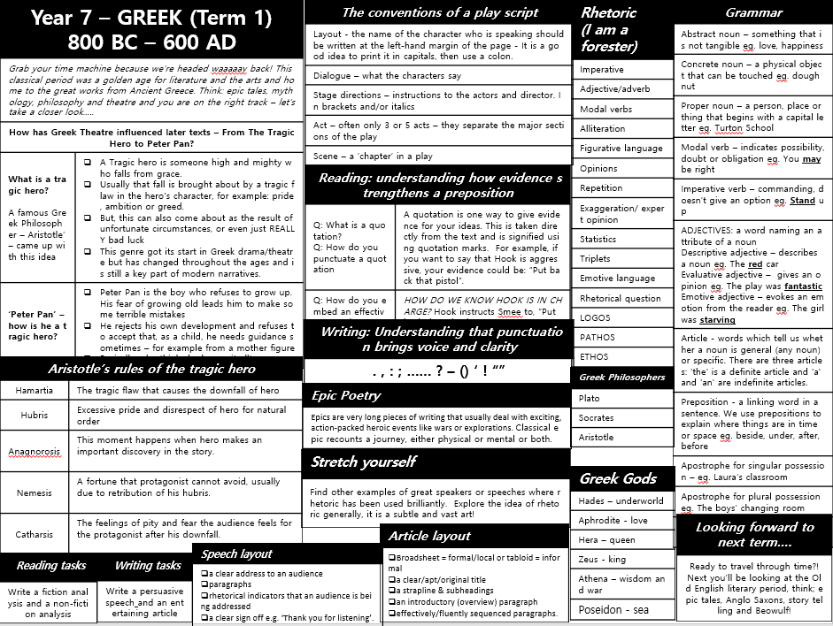  Learning top tip #2  Pupils should start to collect their knowledge organisers ready for the end-of-year tests. Ask your teachers for them so you know exactly what to memorise. Then the hard work begins!  Mrs Lane (Assistant Head Teacher)  Curiosity Question - Music  I sit on the floor and you sit in a chair.  You play with a bow that’s made of horse hair.  I’m played in an orchestra, a nice wooden fellow.  My name is five letters, they call me a ___________. (Ask your Music teacher for the answer!)  Mr Parkinson (Head of Music)

Recommends  All About Mia – Lisa Williamson  Lisa Williamson came to talk to Year 8 in January. All About Mia discusses family dynamics and pressures of being a teenager in the C21st. One family, three sisters. GRACE, the oldest: straight-A student. AUDREY, the youngest: future Olympic swimming champion. And MIA, the mess in the middle. Mia is wild and daring, great with hair and selfies, and the undisputed leader of her friends - not attributes appreciated by her parents or teachers. When Grace makes a shock announcement, Mia hopes that her now-not-so-perfect sister will get into the trouble she deserves. However, it is Mia whose life spirals out of control – boozing, boys and bad behaviour - and she starts to realise that her attempts to make it All About Mia might put at risk the very things she loves the most.  No Fixed Address – Susin Nielsen  Felix Knutsson is nearly thirteen, lives with his mother and pet gerbil Horatio, and is brilliant at memorising facts and trivia. So far, pretty normal. But Felix and his mom Astrid have a secret: they are living in a van. Astrid promises it’s only for a while until she finds a new job, and begs Felix not to breathe a word about it. So when Felix starts at a new school, he does his very best to hide the fact that most of his clothes are in storage, he only showers weekly at the community centre, and that he doesn’t have enough to eat. But Felix has a plan to turn his and Astrid’s lives around: he’s going to go on his favourite game show and win the cash prize. All he needs is a little luck and a lot of brain power . . . Let me know what you think – Mrs Locke (Librarian) | 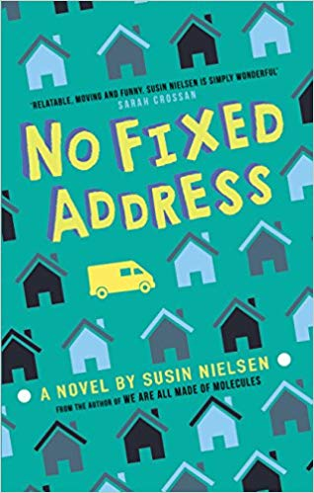  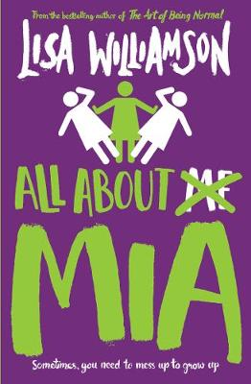

Jump in
Just to let you know about some of the marvellous things going on that pupils can be involved in to really make the most of their time at Turton. This term:
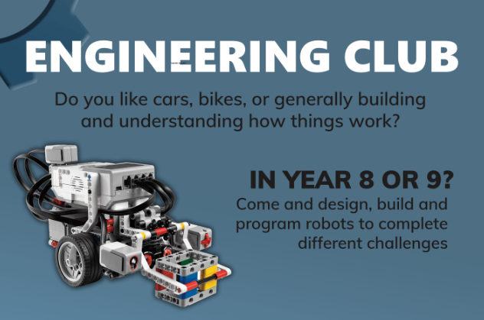
Engineering Club : If you like cars, bikes or generally building things. Then speak to Mr Little about joining this group. Every Thursday 3-4pm in Technology rooms.
Mr Little (Maths/Technology teacher)
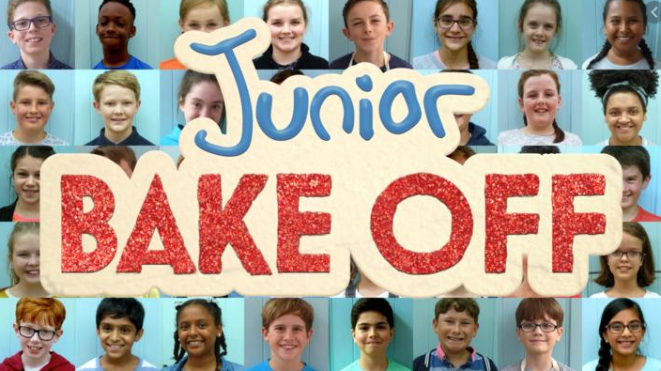
Junior Bake Off competitors are more than welcome to come and practice their entry dishes for the Channel 4 show. Check your school email for information. All KS3 pupils are invited to create food dishes from scratch after school in DT5. Tuesday 3-4 pm.
Mrs Dower (Head of Food).

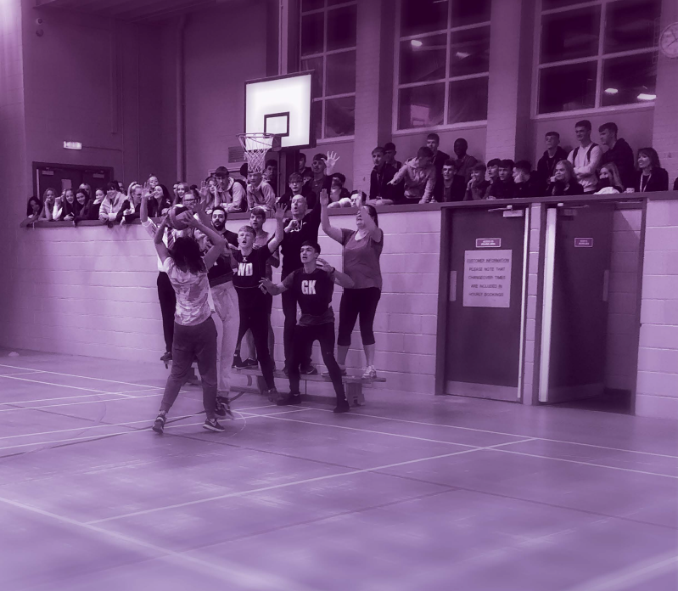
Spotlight: Physical Education
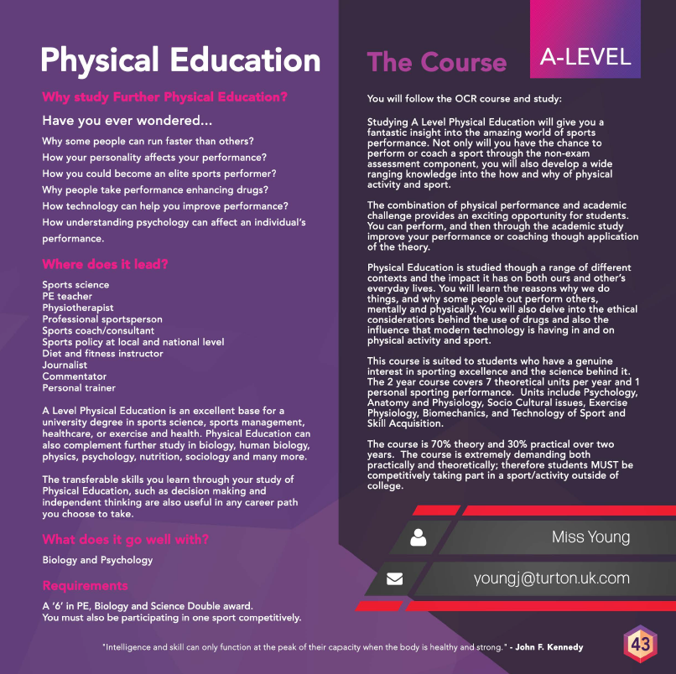
Each term we’ll spotlight an A-level course at Turton, just in case pupils are wondering where excellent learning can take them. Information about all courses is available in our prospectus here: http:/ /www.turtonsixthform.uk.com/. Mrs Bali (Head of Sixth Form)

