Turton

Year 7 Easter Update

A springtime update on what year 7 pupils have been learning this term, just in case they are becoming less forthcoming with age! Additional information about the Scholars’ curriculum is in brackets. All of our knowledge organisers, detailing what will be on our end-of-year tests are here: https://www.turton.uk.com/ks3revision/  - English: Old English, ‘Hobbit’ , Myths & legends (Propp, Anglo-Saxon Chronicles, Völuspá)  - Maths: Algebra, Averages, Fractions (Algebraic Graphs, Equations, Percentages)  - Science: Separating mixtures, Movement, Sensitivity, Plant Cells, Forces (Greater depth)  - History: Medieval, Crusades, Magna Carta (Language & text comparisons, influence & consequences)  - Faith & Ethics: Christianity, Christian Worship, Charities (Greeks, Philosophy of Religion)  - Geography: Maps, Settlements, Rivers, Weather & Tourism (Rise of Manchester, hydrological cycle)  - Spanish: Free time, School and cultural understanding  (French: Ma famille et moi, Latin: Forum and Pompeiian lifestyle)  - Drama: Script writing, Puppet show, Physical theatre (Public speaking, Greek myths)  - PE: The Skeletal system, Health and well-being, Diet  - Music: Understanding Notation (Notation, Rhythm, Renaissance Music)  - Technology: Industrial Revolution, Healthy eating, timber properties (engineering)  - Art: Renaissance, Leonardo da Vinci, Perspective (Albrecht Durer, Filippo Brunelleschi)  - Computing: Algorithms, Problem solving, Decomposition (Bubble sorting & comparison) | 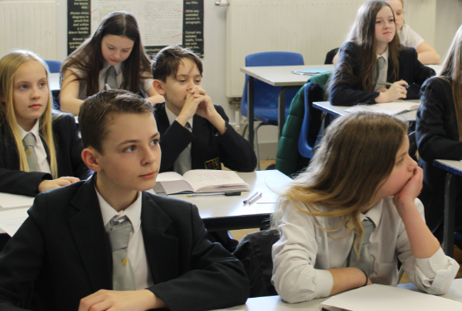
 | 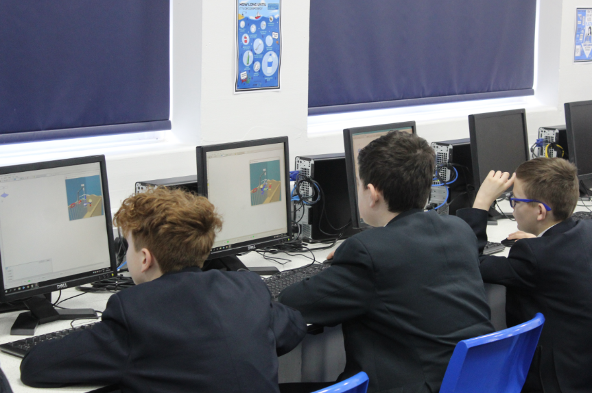

“Curiosity is one of the greatest secrets of happiness.”
Bryant H. McGill
F.O.M.O. (Fear of missing out)  Education moves the world forward, and in the time of so much information being thrust at us all, every minute of every day, it is vital that good education for our students helps them to be the movers and shakers of all our futures. Simple things like hand washing and good hygiene can reduce the spread of bugs dramatically and help all students to attend school fully.  Mrs Bach (Deputy Head Teacher)  Past the halfway point!  As we near the end of another term, time seems to be flying by! The new homework system seems to be working well with the routine of set subjects each day becoming embedded. It would be great if you could support us by checking on homework, making sure they have their zip folder, and asking them to show you what they have done. When parents take an active interest in their child’s homework, it really does make a positive difference. Mr Sykes (Head of Year 7) |  | 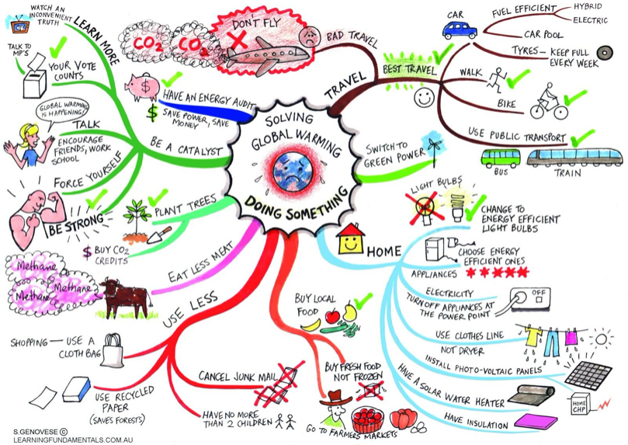  Learning top tip #2  Hopefully pupils have started to collect their knowledge organisers for the end-of-year tests. They could now start to organise their revision notes before actually beginning memorisation. The mind-map is a favourite; grouping ideas with colours, & using images for memory jogs.  Mrs Lane (Assistant Head Teacher)  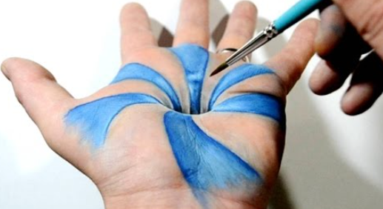  Curiosity Question - Art  How can you do this? (Ask your Art teacher for the answer!)  Ms Tems (Head of Art)

Recommends  Wildspark - Vashti Hardy  A fantastic adventure story. A year after the death of her older brother, Prue Haywood's family is still shattered by grief. But everything changes when a stranger arrives at the farm. A new, incredible technology has been discovered in the city of Medlock, where a secretive guild of inventors have developed a way to capture spirits of the dead in animal-like machines, bringing them back to life. However, to find her brother, she needs to find a way to get the ghost machines to remember the people they used to be. Yet if Prue succeeds, all of society could come apart...  Runaway Robot – Frank Cottrell-Boyce  Runaway Robot is a funny and heart-warming adventure about two best friends helping put themselves back together. When Alfie goes to Airport Lost Property, he finds more than he bargained for. A lot more. Because there's a giant robot called Eric hidden away on the shelves. Eric has lost one leg and half his memory. He's super strong, but super clumsy. He's convinced that he's the latest technology, when he's actually nearly one hundred year's old and ready for the scrap heap. Can Alfie find a way to save Eric from destruction - before Eric destroys everything around him? Let me know what you think – Mrs Locke (Librarian) | 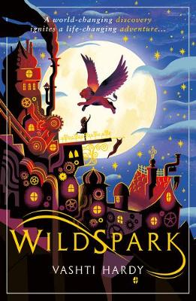  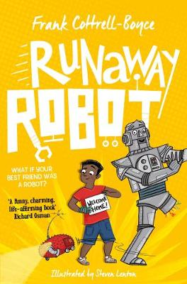

Jump in
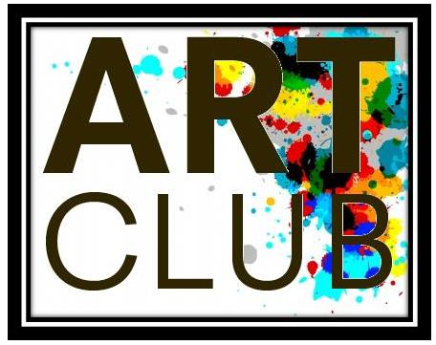
Just to let you know about some of the marvellous things going on that pupils can be involved in to really make the most of their time at Turton. This term:

Art Club: Open to all artist who want to come and create their own work or get involved in a creative project. Come to the art rooms every Thursday from 3pm – 4pm.
Ms Tems (Head of Art)
Textiles Club: Come to textiles to learn skills and trial all the specialist equipment, colour application and make a simple quality product. Or think about the environment and try up-cycling and recycling. Why not come along to see what you can do.
Mrs Murphy (Head of Textiles)

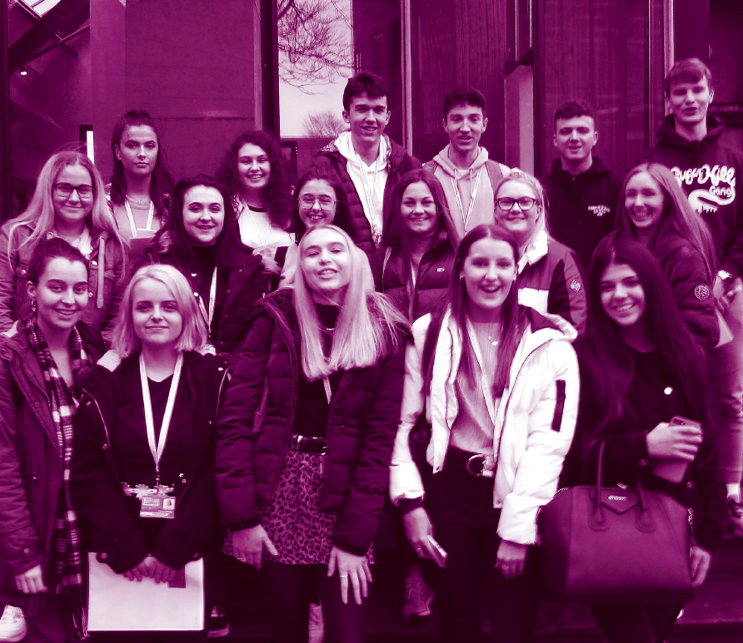
Spotlight: A-level Chemistry

Each term we’ll spotlight a course at Turton sixth form, just in case pupils are wondering where excellent learning can take them. Information about all courses is available in our prospectus here: http://www.turtonsixthform.uk.com/
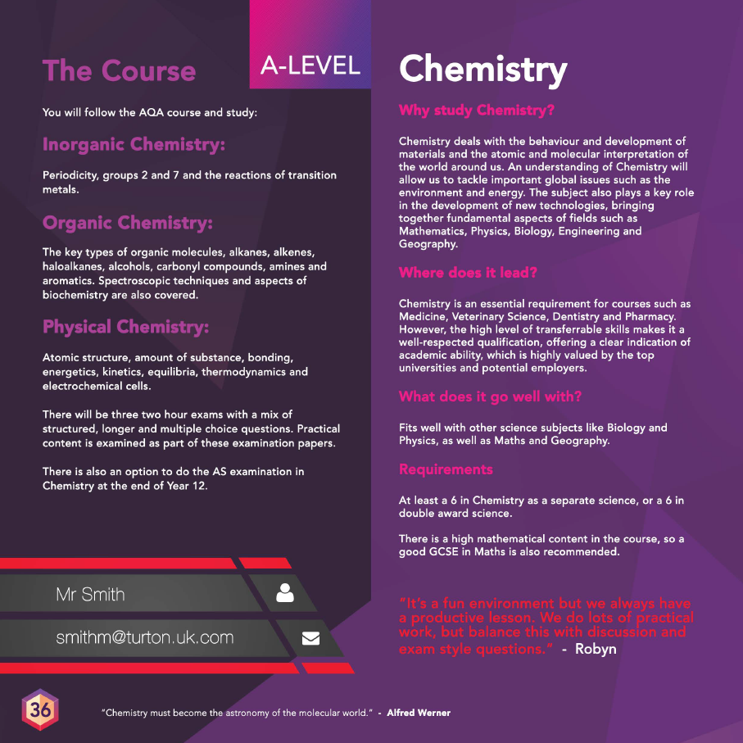
Mrs Bali (Head of Sixth Form)

