50 Other Things To Do If Learning From Home

Google Map Games  https://geoawesomeness.com/10-top-google-maps-games-of-all-times/  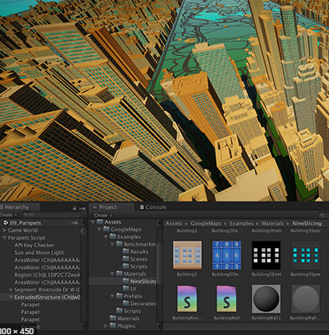 | Theraputic colouring  There are some free sheets here, or make your own: https://printmandala.com/  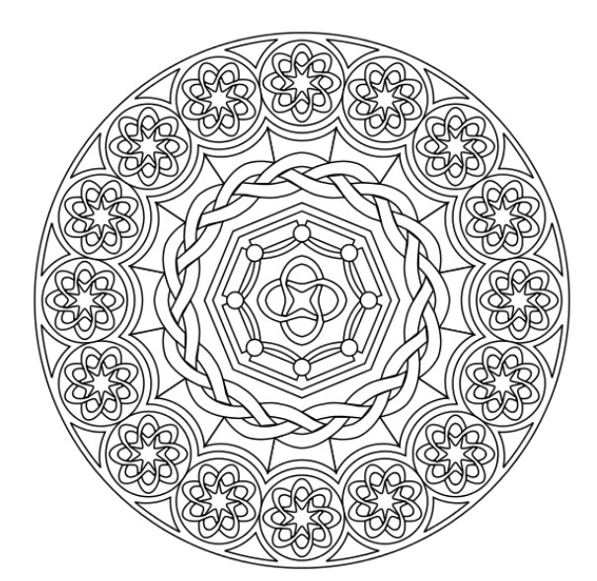 | Philosophy games  https://www.philosophersmag.com/games  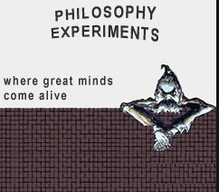 | GCSE Bitesize  https://www.bbc.co.uk/bitesize/levels/z98jmp3  https://www.bbc.co.uk/bitesize | Keep tidy at home  Use this time for a clear out of your room. Open the curtains and windows to let fresh air in.  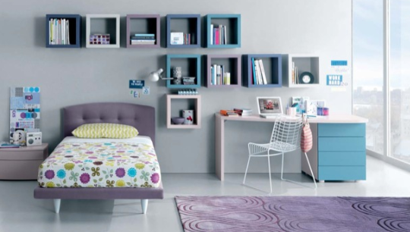 | What can I read?  https://www.waterstones.com/category/childrens-teenage/teen-and-young-adult  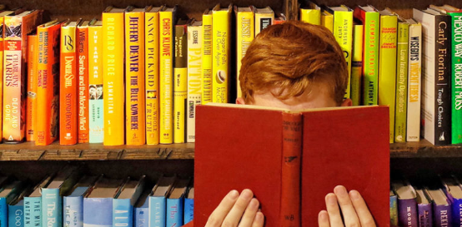 | Go on a school trip…without leaving your home  https://www.familiesmagazine.com.au/museum-virtual-tours/  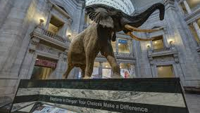 | Geography games  https://www.geoguessr.com/  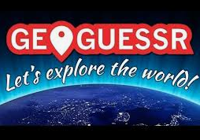 | Science experiments at home  https://www.jamesdysonfoundation.co.uk/resources/challenge-cards.html?gclid=EAIaIQobChMIjLWAqLOf6AIVVuDtCh18SQjdEAAYASAAEgI1gPD_BwE  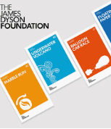 | Plant a window box – spreading some joy to your neighbours.  You’ll need to order some seeds and compost online, or you can take cuttings and soil from your own garden.  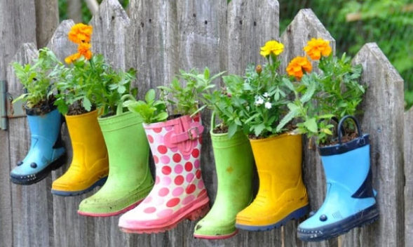
Write a diary about your experience  This is an event that affects the whole world. Why not write down what it has meant to you?  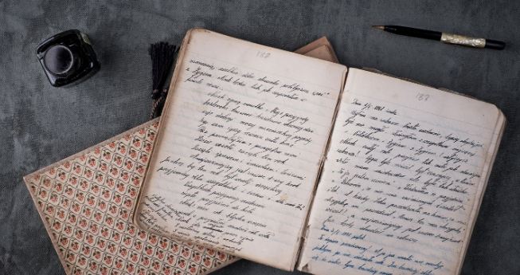 | Keep up to date with the news  Don’t overload yourself, as the news companies are trying to write dramatic headlines to make money. But find a newspaper that you trust. | Play board games with your family  https://www.thespruce.com/board-games-for-college-kids-3570593  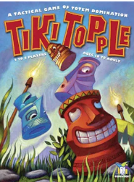 | Get fit and healthy  You can try the ideas on here, or even running up and down the stairs, or dancing to music:  https://www.nhs.uk/live-well/exercise/gym-free-exercises/ | Try some baking  https://www.bbcgoodfood.com/recipes/collection/kids-baking  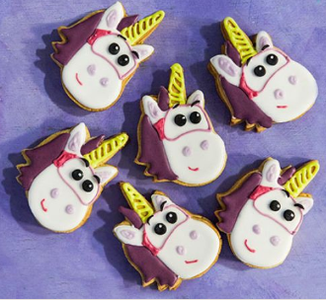 | Learn something that we don’t teach at school  https://www.futurelearn.com/courses | Recommended podcasts  https://player.fm/podcasts/Gcse | Learn to sing  http://www.bbc.co.uk/sing/learning/  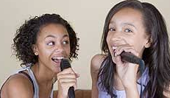 | Write that story that keeps popping back into your head… | Make someone a cup of tea  It’s quite a stressful time at the moment, so take care of others in small ways
Watch something different…  These films are recommended by a man that actually knows about films https://www.theguardian.com/film/2019/jul/21/25-best-childrens-films-mark-kermode  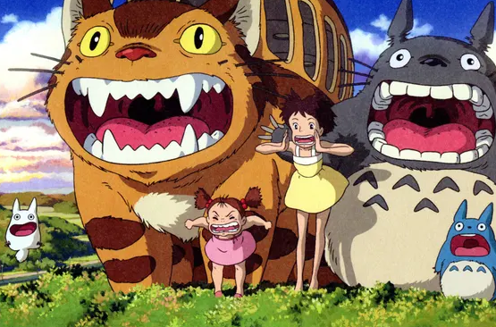 | Puzzles to stretch the brain  https://sharpbrains.com/brainteasers/  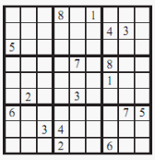 | Dig out your old jigsaws – the more pieces the better  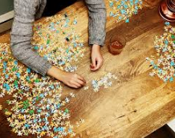 | Volunteer for a charity  https://www.charitychoice.co.uk/blog/10-amazing-ways-to-help-charity-without-leaving-the-house/80 | Become a great artist  Draw anything and everything, or you could try copying one of the great artists: https://www.theguardian.com/artanddesign/jonathanjonesblog/2014/mar/21/the-10-greatest-works-art-ever  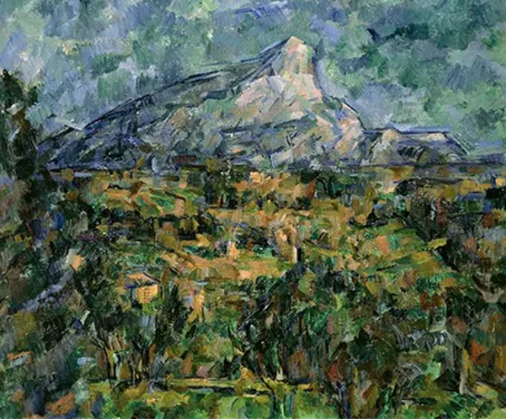 | Listen to something different  https://www.classicfm.com/discover-music/best-classical-music-for-kids/  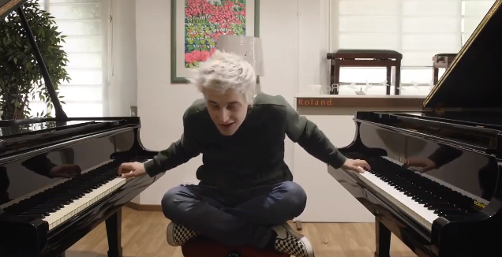 | Get crafty  Make your own project, or there are some ideas here  https://diyjoy.com/cool-diy-projects-for-teenagers/ | 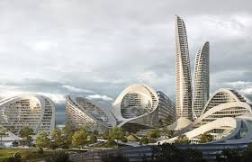  Design a city of the future | Research a place you’d love to live | Write a letter to your future self
Re-design the school logo. What would you include? | Pretend to book your dream holiday include the cost and the itinerary | Create a collage…all about you!  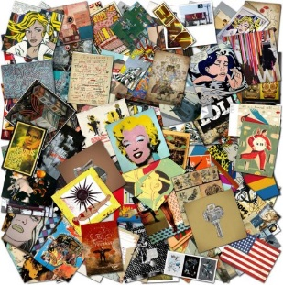 | Write a letter to say thank you to someone  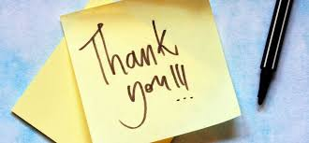 | Hegarty maths  https://hegartymaths.com/ | Science . | Get yourself driver ready….  How does an engine work?  https://mocomi.com/how-does-a-car-engine-work/  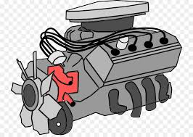 | Ask a believer …  Ask a religious believer a question….  http://pof.reonline.org.uk/ | A history of Bolton  Research the history of where you live…  http://www.localhistories.org/bolton.html  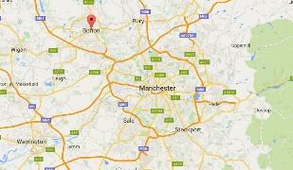 | Go to the zoo  https://kids.sandiegozoo.org/  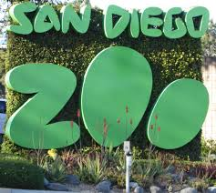
Off to Yellowstone USA  https://www.nps.gov/yell/learn/photosmultimedia/virtualtours.htm  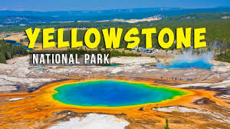 | Next stop Mars  http://www.accessmars.withgoogle.com/  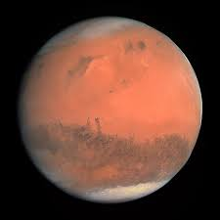 | Which country….  https://www.countryreports.org/  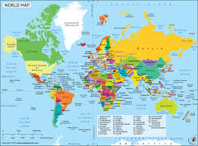 | Learn to touch type  https://www.typingclub.com/ | Explore Space….  https://www.nasa.gov/ | Challenge yourself to a ‘no-phone’ day | Build a den….  Remember it used to be fun. Give the den a purpose – reading/art/ meditation/etc.  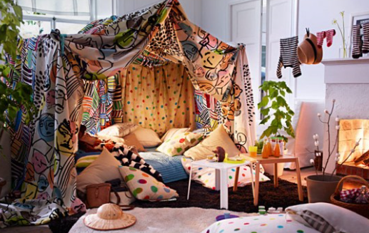 | Meditate  You can do your own slow breathing or maybe try this one? http://mindfulnessforteens.com/guided-meditations/  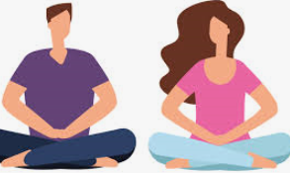 | What about non-fiction books too?  https://www.penguinrandomhouse.com/books/nonfiction-teen-young-adult | Origami  You can try or own designs or maybe start her for some help…  https://www.youtube.com/results?search_query=origami+easy  