6 Mark Question Structure
GCSE PE - INDEPENDENT LEARNING TASK
SOMATOTYPES
Extreme body types (somatotypes) are classified as endomorph, mesomorph or ectomorph.
Discuss whether an extreme mesomorph would be the ideal body type for endurance activities such as long distance running.
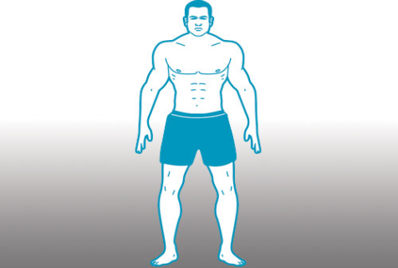
Use the boxes on the left to help you structure your answer. Tick the little box in the corner when you have finished each part of your answer.
Identify each somatotype and give a characteristic of each one e.g. an ectomorph has long thin limbs.
(L1)
_____________________________________________________________________________________________________________________________________ _______________________________________________________________________________________________________________________________________________________________________________________________________________________________________________________________________________________________________________________________________________________________________________________________________________________________________________________________________________________________________________________________________________________________________________________________________________________________________________________________________________________________________________________________________________________________________________________________________________________________________________________________________________________________________________________________________________________________________________________________________________________________________________________________________________________________________________________________________________________________________________________________________________________________________________________________________________________________________________________________________________________________________________________________________________________________________________________________

Develop your answer as to whether a mesomorph is suitable to long distance running.

(L2)
Develop your answer with examples and a conclusion e.g. which somatotype would be better suited to a long distance runner and why.(L3)
Mark Scheme
Level 1 (1-2 marks) | Simple statements only e.g. a mesomorph is muscular and ectomorph is thin, mesomorphs have more muscle therefore are heavy so slowing the performer.
Level 2 (3-4 marks) | Developed statements e.g. a simple statement with an explanation or additional information about the body type e.g. ectomorphs have a lighter frame than other body types meaning less weight to carry therefore they have more pace.
Level 3 (5-6 marks) | Developed statements with relevant examples (balanced) Conclusion provided e.g. an ectomorph has a lighter frame therefore less demanding physically than for other body types to complete the distance. Therefore, although a mesomorph could run in this event it is not ‘ideal’. The ectomorph body type for a long stance runner would be better to be an ectomorph.

