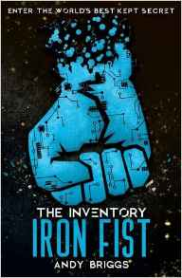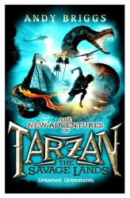

**RRP £6.99 OUR PRICE £6**Hidden under a small suburban town, the Inventory is a collection of the most incredible technology the world has NEVER seen: invisible camouflage, HoverBoots, indestructible metals, and the deadly war robot Iron Fist. Dev's uncle, Charlie Parker, is the Inventory's mild-mannered curator, with security provided by Eema, a beyond-state-of-the-art artificial intelligence system. But security is catastrophically breached when Lot and Mason from school turn up unexpectedly and, hot on their heels, a ruthless gang of thieves working for the Collector and the Shadow Helix organization. If the thieves succeed in their goal to seize the Iron Fist, Dev, his friends, and the world are in a whole heap of trouble.

**We MUST have Pre-Orders for this book it’s £17.99 We can sell for £12.99  
But we can’t afford to carry lots and not sell them, so please order if you DO want.**

There's no going back, Agent. Once you enter this book, your training will begin as you join the secret world of spies. You'll rise through the ranks from recruit to secret agent, learning a host of skills to put into covert operation immediately. Get the scoop on some of the biggest agencies in the world, discover the coolest gadgets out there, and crack some fiendish codes and lots more. For aspiring spies aged 8 years and up. Great for on-the-road entertainment.

There are three action packed jungle adventures featuring Tarzan. They really are super cool and very clever, Andy updates him so well.

Ideally you should read them in order, but if you just fancy the look of any, choose that one, you can always read the others later.

**RRP £6.99 OUR PRICE £6**